**SMART STAR EXAMINATIONS BOARD**

**END OF TERM I EXAMINATIONS - 2024**



**ENGLISH**

**PRIMARY TWO**

***Time Allowed: 2*** *hours* ***15*** *minutes*

**Name...........................................................Stream............**

**INSTRUCTIONS**

1. ***Avoid unnecessary crossing of work.***
2. ***Use very good handwriting.***

**SECTION A (40 MARKS)**

**1. Draw the pictures**

|  |  |
| --- | --- |
| **chalkboard** | **tree** |
|  |  |

**2. Join these words to form compound nouns**

a) class + room = ___________________

b) gate + keeper = _________________

**3. Write "a" or "an" in the gaps.**

a)That is ______umbrella.

b) Jane has ______ long dress.

c) ________owl is a wild animal.

**4. Fill in the missing letters.**

p___ncil

fl__g

**5. Write a small word from a big word.**

blackboard __________________

policeman ___________________

6**. Arrange the following words in ABC order**

uniform, flag, hall, medicine

________________________________________

nephew, aunt, mother, cousin

________________________________________

**7. Complete the riddle correctly**

I am a domestic animal . My young one is a calf.

You get meat and milk from me. Who am I?

You are a ___________________________

**8. Give the plural form of the circled words.**

My dress is clean. __________________

I saw a fly on the wall. _______________

Peter lost his pencil. __________________

**9. What is this? (That ……………/It……………)**

(a) 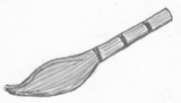

__________________________________________

(b)

**______________________________________**

****(c)

**________________________________________**

**SECTION B (60 MARKS)**

**21. Write in full form**

Sch __________________

Rd. __________________

**22. Use Yes, it is or No, it is not.**



Is this a flag?

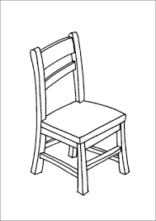 ___________________________

Is this a ruler?

___________________________

**23. Give the opposite of the underlined words.**

a) My mother is sick today. _________________

b) He has a long pencil. ___________________

c) Our classroom is very dirty. _______________

**24. Complete correctly.**

As green as _____________________

As cold as ______________________

**25. Change the verbs in brackets to the correct tense.**

a) He is _______________ meat now. (eat)

b) That ball is ______________(my)

c) They are________________their teeth now. (brush)

d) An elephant is _____________than a goat. (big)

**26. Match correctly.**

Jane it

Peter they

The dog he

Musa and Ali she

**27. Rearrange these words to form correct sentences.**

a) sons has he two.

__________________________________________

b) name is What your?

___________________________________________

**28. Rewrite the sentences as instructed in brackets**

a) Tom has a pencil. Tom has a bag. (Use……and……..)

______________________________________________________

______________________________________________________

b) Ruth is crying. She is sick. (Use……because……..)

______________________________________________________

______________________________________________________

c) I don’t like posho. I like beans. (Use……but……..)

______________________________________________________

______________________________________________________

d) Daddy is kind. Mummy is kind. (Begin: Both……..)

______________________________________________________

**29. Use the given words to complete the story correctly.**

Water, children, Martha, food, mother

There are five people in Mr. Kasule’s family. Mrs. Kasule is the ________________. She cooks ___________for the family and

takes care of the ______________. They have three children, Oscar, Jude and ___________. The children clean the home, fetch_______________ and wash utensils. They all work together.

**30. Use a correct word to complete the sentences correctly.**

a) The milk is _______the glass.



b) 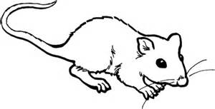The rat is ____________ the table.

**END:**